Covid-19 Vaccine Digital Distribution Proposal

The Covid-19 pandemic in India is a part of worldwide pandemic of coronavirus disease 2019 . In March, after the lockdown was imposed, the United Nations (UN) and the World Health Organization (WHO) praised India's response to the pandemic as 'comprehensive and robust', terming the lockdown restrictions as 'aggressive but vital' for containing the spread and building necessary healthcare infrastructure. India is among one of countries which had been severly hit by this deadly virus .
Ten months into the Covid-19 panademic ,the expert group on Corona virus vaccine is formulating stratergies to plan out the distribution of the vaccine in the country .Goverment is planning stratergies on how to distribute vaccines to fellow citizens once it's ready .India is already working on putting a well-established vaccine delivery system in place. This digitised network along with digital health IDs will be used to ensure immunisation of our citizens,” said our Honourable Prime Minister Narendra Modi .
So as our country is moving towards digitisation ,I have come up with a proposal on how we can manage the distribution of vaccine through digital platform .
Scope : Till now the Electronic Vaccine Intelligence Network (eVIN) is being used by the State/UT governments in India to monitor the supply chain of Covid response material.This has been used with the requisite customization during the Covid pandemic for ensuring continuation of the essential immunization services.eVIN aims to support the Government of India’s Universal Immunization Programme by providing real-time information on vaccine stocks and flows, and storage temperatures across all cold chain points in these states.
Now as real-time information on vaccine stocks and storage information about all chain points in different states are provided to us by the eVIN , I aim to create a system that can use this information and help the goverment in making a similar digital system that can help with proper distribution of vaccine across the country .
Process Description : The working of this system will start with processing the information provided by the Ministry of Health and Family Welfare about the number of active cases of coronavirus . From there we will also get the State wise data of coronavirus patients .Than the data will be taken from the eVIN regarding the number of vaccine available .
Now once we have all the data regarding the number of patients and vaccine available ,my proposed system will process that information and carry out the calculations that how these vaccines should be distributed in a way that every state would get the amount of vaccine which is proportional to the numer of cases in it .
Now my system will work in a way that the vaccine would be made available to the patients and than to the corona warriors of our country like the doctors ,nurses ,medical staff ,police etc .And to avoid delay of delivery of vaccine to the normal people ,my proposed system will take measures that some portion of total percentage of vaccine is also made available to normal citizens simultaneouly along with the corona patients and corona warriors .
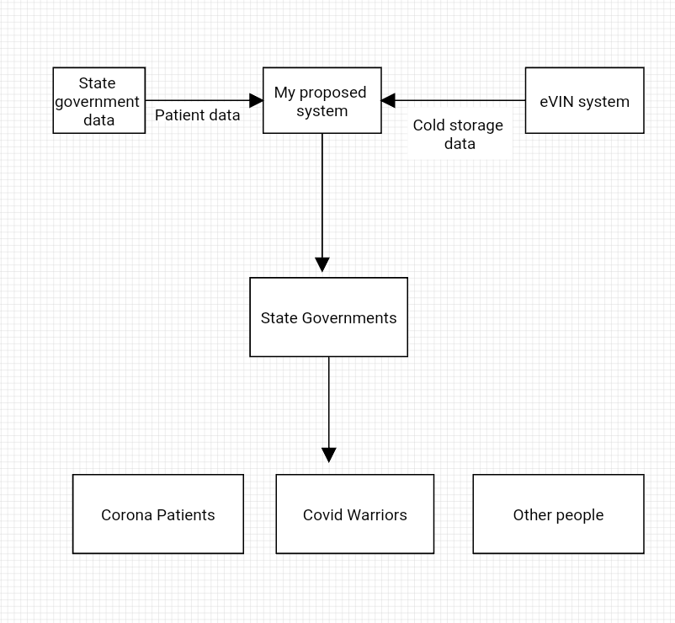

Technology Used :
Language : Java ,JSP(Java Server Pages) .
Database : MySQL
Why JSP ?
1) One of the main reason of using JSP in my system is that ,JSP has access to all the major Java API's including JDBC.
2) JSP tags allows us to write Java code inside static HTML web pages .
3) It is more convenient to write regular HTML than to have println statements that generate HTML which is done in Servelets .
4) It is comparitively faster as it has access to all the Java API'S so there is no need of using any external API which might slow down the proccessing of system .
Testing methods :
1) Unit Testing : It focuses on smallest unit of software design. In this we will test all individual unit or group of inter related units of our proposed system .
2) Integration testing : The objective is to take unit tested components and build a program structure that has been dictated by design.Integration testing will be performed in which a group of components will be cobined to test the output .
3) Regression testing : Every time new module is added leads to changes in program. We will perform regression testing to make sure that whole component works properly even after adding components to the complete program.
4) Alpha testing : This is a type of validation testing.It is a type of acceptance testing which I will perform before releasing my final system . which is a type of acceptance testing which I will be performing before releasing my final project presentaion .
Limitations :
1) The system will have to rely of the information provided by Ministry of Health and Family Welfare for knowing the number of coronavirus cases in the country .
2) The system will get the information regarding the availability of vaccine from Goverment only through eVIN .
Further Improvement :
1) My proposed system can easily be modified with simple changes in way that it can also help in tracking of vaccine for a particular person and he/she can track his/her vaccine .
2) As the number of people to be vaccinated in India is more ,it will require more infrastructure to easily handle such amount of people ,so we can keep a track of such places statewise in my system which will help the people to easily locate their vaccination centers .And google maps can be integrated for the citizens ease .
3) SMS api can also be integrated so that citizens can be given the information regarding the date and place where he will be vaccinated through an SMS .
Conclusion : The expert group on Corona virus vaccine is formulating stratergies to plan out the distribution of the vaccine in the country .So as our country is moving towards digitisation ,this project system of mine is a small suggestion that how Vaccine distribution in our country can be managed efficienltly using my system .
Project Guide :
Mr. Jugendra Dongre Sir .

